IR Module Fault

- Open the cabinet door.
- Locate the Siemens drive modules (Please reference the pictures and diagrams for more information.)
- Look for an alarm code on the Spindle Drive, or an error light on one of the axis drive modules or IR Module. (From left to right the modules are in the following order. IR Module, Spindle Module, X-Y axis module, and the Z-axis module.)
- If there are no lights visible on the Siemens Drive package, Verify:
  - 400 VAC supply to the IR Module
  - Machine breaker is turned on
- If the a & b are correct, and there are no lights are present on the drive unit, perform the following procedure
  - Turn off the main breaker to the machine.
  - Let the machine sit for 10 minutes in a powered down state before continuing. High voltage (600VDC) is still present in the drive module after the machine is powered down! Failure to do so will result in personal injury!
  - When the 10 minutes has expired, remove all of the ribbon cable jumpers from the front of the drive module. (Take note as to how they came off for re-assembly)
  - Remove the plastic covers from the bus jumpers.
  - Verify 0 VDC between the two bus bars.
  - Using a Torx bit screwdriver, disconnect the bus jumpers between all of the drive modules.
  - Turn on the main breaker. Take care not to come into contact with the now exposed bus!!
  - If the green and yellow led’s do not come on when power is applied, the IR Module has failed. Please call a Hurco Service representative.
  - If the Green and yellow led’s do come on, turn off the main breaker, and wait
Ten minutes for the module to discharge voltage!
  - After 10 minutes, attach the jumpers and ribbon cables between the IR Module and the next module to the right. (Spindle drive module)
  - Turn on the main breaker. (Do not come into contact with exposed bus!) If the led’s on the IR Module come on, and you get a display on the Spindle Drive module, Turn off the Main Breaker, wait 10 minutes, and connect the next module in line. (X & Y Axis drive module.) Continue this procedure till you find the module that causes the problem.
- If the led marked “M” is lit, check the connections to the affected motor.
(NOTE: A1 on the dual axis module is X, and A2 is Y axis)
- If the led marked “A” is lit, perform the following steps:
  - Check the integrity of the drive by swapping the axis drives.
Example: the X – Y axis drive module is showing an “A” alarm on section
A1. The error is in the X axis.
- Mark, remove, and swap the X and Y Armature leads, marked A1 (X) and A2 (Y) from the bottom of the X – Y drive section.
- Exchange connectors X311 (X) with X313 (Y).
- Exchange X331 (X) with X332 (Y)
- If the A led remains in the “A1” section, The X axis portion of the drive has failed
- If the led moves to the “A2” section, the problem is in the X axis motor or cables.
- To determine whether the Plug In module or the Power module has failed, perform the following procedure.
  - Turn off the main breaker.
  - Allow 10 minutes for the voltage to dissipate in the drive.
  - Disconnect the bus jumpers from the affected axis drive module
  - Remove the “A1” and “A2” armature plugs.
  - Using a voltmeter set to “Diode Check”, measure between the top bus terminal and each one of the armature connections on the drive for the affected axis.
  - Swap the leads and check again.
  - Now, repeat the procedure from the bottom bus terminal.
  - A normal drive shows some continuity one way, and when the leads of the voltmeter are swapped, should show no continuity. If continuity is found with both ways, the power module needs to be replaced.

Alarm LED’s for Siemens Drive

Siemens Spindle Drive Error Codes
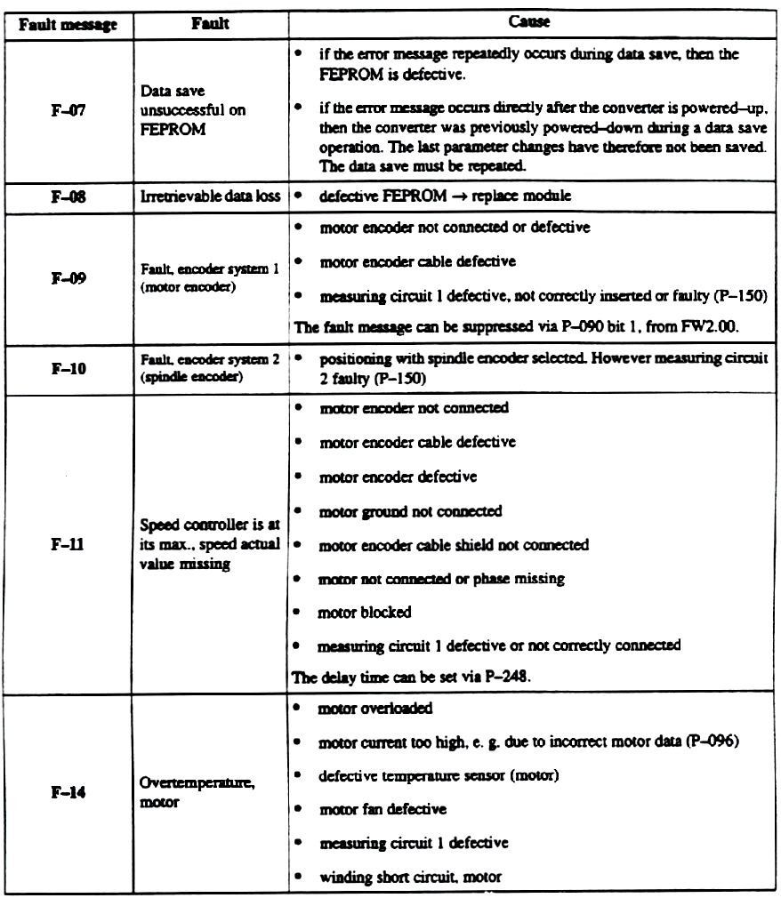

Siemens Spindle Drive Error Codes (Cont.)
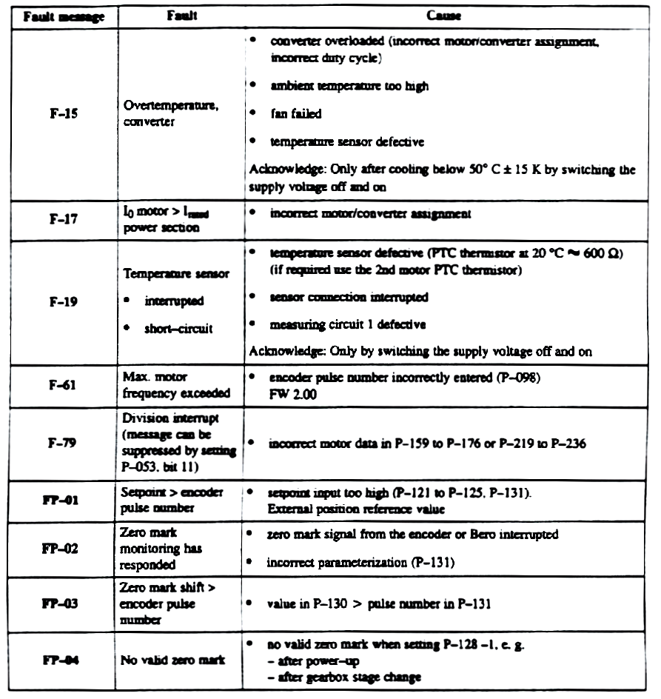

Siemens Drive Modules
